Circuitmaster Designs Ltd
PROfiler Temperature Profiling System
User Manual

Accuracy,Performance,Value
PROfiler
© Circuitmaster Designs Ltd
Kingsway West Business Park • Rochdale,Lancs,UK
Phone +44(0)1706 630606 Fax +44(0)1706 510401
Email Profiler@circuitmaster.co.uk
www.circuitmaster.co.uk

Table of Contents

Product warranty 3
Limitation of Warranty 3
Trademarks 3
Document ChangeHistory 3
1.0 Introduction 4
1.1 About this manual 4
1.2 Assumptions 4
2.0 General Description 4
2.1 The Data Logger Unit 5
2.1.1 Status Led 5
2.1.2 Charge Led 6
2.1.3 Mode Button 6
2.1.4 RF Socket 6
2.1.5 Comms Socket 7
2.1.6 Thermocouple Sockets 7
2.2 The Thermal Barrier 8
2.3 PC DownLoad Cable 8
2.4 DC Power Supply 9
2.5 PC transceiver unit 9
2.6 PC Windows Software 9
2.7 Software Installation 10
2.8 Siteing the PC RF transceiver 10
2.8 Testing the System 11
2.8.1 Testing Direct Communications 11
2.8.2 Testing RF Communications 11
3.0 Profiling Basics 12
3.1 Operating Modes 12
3.1.1 Standalone Mode 12
3.1.2 Real Time Mode 13
3.2 Profiling a Board With PROfiler 14
3.2.1 Preparing the test board 14
3.2.2 Where Do I position the Thermocouples ? 14
3.2.3 Setting up the PROfiler system 16
3.2.4 Setting Up Oven Zones 16
3.2.5 Creating / Loading Oven Templates 18
3.2.6 Process Settings 19
3.2.7 Recording the Probe Locations 20
3.2.8 Setting up the PROfiler datalogger 21
3.2.9 Loading the System into the Oven 23
3.2.10 Loading the datalogger into its Heat Barrier 23
3.2.11 Recovering the System from the Oven 24
3.2.12 Internal Logger Temperature 25
3.2.13 DownLoading data from the datalogger 25
3.3 Saving your profile information 26
3.4 Measuring process metrics 26
3.4.1 Displaying board delta–T 27
3.4.2 Displaying Positive and Negative Rates Of Change 28
3.4.3 Displaying the time above the liquidous temperature 29
3.5 Adding a Process Tolerance 30
3.6 Overlaying a Profile 31
3.7 Exporting Data 31
3.8 Printing 31
3.9 Alarms 32
3.10 Default Settings 32
4.0 Care And Maintenance 33
4.1 Battery Charging 34
4.2 Changing the Batteries 35
4.3 Software Updates 35
4.4 Product Conformance 36
5.0 Technical Specification 37

Product warranty

This product, and associated software media, has a warranty against defect in materials and workmanship for a period of one year from the date of shipment. During this period Circuitmaster Designs Ltd will at its discretion, either repair or replace products that prove to be defective. The associated software is provided ‘As is’ without warranty.

Limitation of Warranty
The foregoing warranty does not cover damage caused by accidental misuse, abuse, neglect, misapplication or modification.
No warranty of fitness for purpose is offered. The user assumes the entire risk of using the product. Any liability of Circuitmaster Designs Ltd is limited exclusively to the replacement of defective materials or workmanship.

Trademarks
Microsoft™ and Windows95™,Windows98™ and WindowsNT™ are registered trademarks of Microsoft Corporation.

Document Change History
First Edition V1.0 JUNE 1999 : Initial draft
First Revision V1.1 DEC 1999 : Release V2.0 Software

When using this document keep the following in mind:
- This document may be, wholly or partially, subject to change without notice.
- All rights reserved. No one is permitted to reproduce or duplicate in any form, a part or all of this document without permission from Circuitmaster Designs Ltd.
- Circuitmaster Designs Ltd is not responsible for any damage to user equipment resulting from accidents or any other causes during operation according to this document.
Copyright © Circuitmaster Designs Ltd 1999 All rights reserved.

1.0 Introduction

This manual describes the use of the PROfiler temperature profiling system. PROfiler is an accurate 6 channel temperature profiling system primarily aimed at monitoring reflow and wave soldering applications. The system comes complete with Windows 95/98/NT compatible software which allows the user to quickly and easily capture and analyse temperature profiles.
The system has been designed to offer unprecedented value for money; offering features as standard which are expensive option on other systems. Particular attention has been given to making the system easy and intuitive to use.

1.1 About this manual
This user manual is broken down into 5 sections. This section contains material relating to the structure and content of the document.. Section 2 describes the installation procedure which should be followed and system requirements. In addition this section introduces you to the various parts of the system and how they are used. Profiling basics are covered in section 3, with step by step instruction on how to use the system. Section 4 deals with care and maintenance of the system and section 5 is a summary of the units technical specification.

1.2 Assumptions
It is assumed that the reader has a basic working knowledge of soldering technology and is experienced in using and installing Microsoft Windows applications on PC compatible computers.

2.0 General Description
PROfiler is a highly accurate temperature profiling system aimed at the monitoring of soldering processes. The system consists of the following elements:-
- 6 channel datalogger fitted with rechargeable batteries, optionally fitted with RF transceiver
- Stainless steel thermal barrier
- PC Download cable
- 6 Type K thermocouples
- DC Power supply
- Optionally, PC RF transceiver and serial lead
- PC Windows software.

2.1 The Data Logger Unit
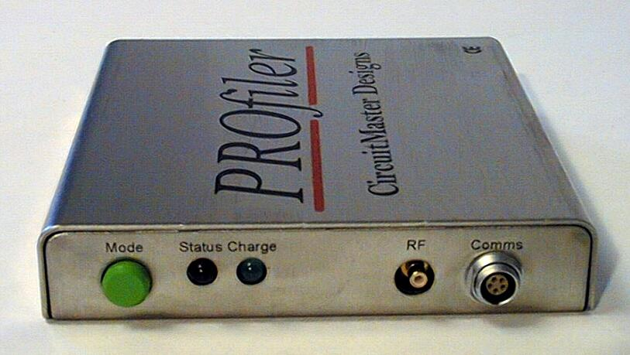
The PROfiler data logger is a battery powered unit designed to measure temperature from a number of thermocouples. The standard data logger unit is fitted with six thermocouples channels, which can be sampled and stored at a predetermined rate. At least 10,000 points per channel can be held in internal memory and downloaded to a PC via a serial lead. Additionally if the RF telemetry option is fitted, the data can be transmitted to the PC and plotted on screen in real time.
The unit is powered from two AAA sized NiMh rechargeable batteries. This approach allows the convenience of rechargeable batteries, whilst allowing standard alkaline batteries to be used if required. The data logger features the very latest in measurement technology, one particularly noteworthy feature being very high rejection of mains frequency interference.

2.1.1 Status Led

The Status led provides visual feedback to the user as to the current mode of operation of the unit. There are three modes of operation depicted as follows:-

Status Led | Logger State
SLOW FLASH | IDLE
FAST FLASH | LOGGING
OFF | POWERED DOWN

2.1.2 Charge Led
The green charge led shows when the datalogger’s batteries are being charged. There are two battery charging modes depicted as follows by the charge led.

CHARGE LED | CHARGING MODE
ON | FAST CHARGE
FLASHING | TRICKLE CHARGE

Battery charging is discussed in more detail in section 4.1

2.1.3 Mode Button

The Mode button has three functions:-
- With the unit powered off (Status led off) momentarily pressing the mode button until the status led lights, powers up the logger to the IDLE state. This is signified by a slow flash on the status led. If the RF telemetry option is fitted, the RF transceiver is powered up and the logger is ready to receive commands from the PC.
- With the unit in the IDLE state (Status led flashing slowly) momentarily pressing the mode button will cause the logger unit to start logging - STANDALONE LOGGING MODE. This is signified by a fast flash on the status led.
- At anytime, if the mode button is pressed and held until the mode led goes off, the logger will power down.

2.1.4 RF Socket

The RF socket on the front panel is for fitment of the RF antenna. Please note that this socket is fitted regardless of whether the RF telemetry option is fitted.

2.1.5 Comms Socket

The Comms or communication socket fitted to the front panel, is a five pole connector which is provided for two main reasons:-
- The connector provides a serial interface to the datalogger which is used for communication with a PC or other device. Primarily this is used to send and retrieve data using the pc download lead provided. Secondly this same feature allows new software to be downloaded to the logger to upgrade it in the field, should this be necessary for any reason. Additionally, this same mechanism is used for attaching other peripheral equipment such as the PROwave wave soldering pallet to the datalogger unit.
- The connector also allows DC power to be connected to the logger for charging the batteries and/or powering the unit.

2.1.6 Thermocouple Sockets
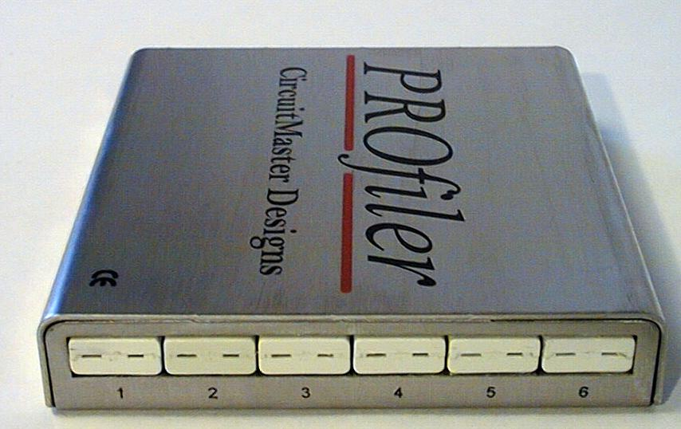
There are six thermocouple sockets fitted as standard to the rear panel of the logger unit. The sockets allow type K thermocouples with standard miniature thermocouple plugs to be easily attached to the unit. The channel numbers referred to in the PROfiler PC software correspond with those marked on the datalogger cover.

2.2 The Thermal Barrier
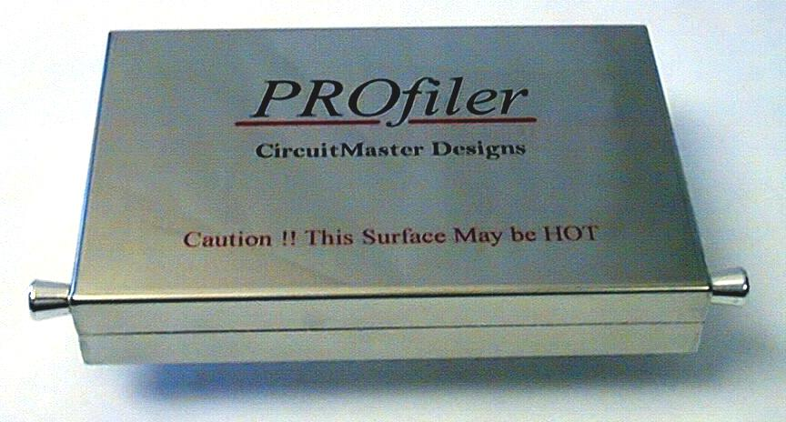
The thermal barrier provides protection for the PROfiler datalogger unit from the harsh environment of a typical reflow or wave soldering machine. The stainless steel barrier provides protection in two ways:-
- The polished stainless steel barrier helps reflect radiated heat
- The special insulation material helps protect from conducted heat

The logger unit should always be used in conjunction with the thermal barrier when used in reflow soldering applications.

2.3 PC DownLoad Cable
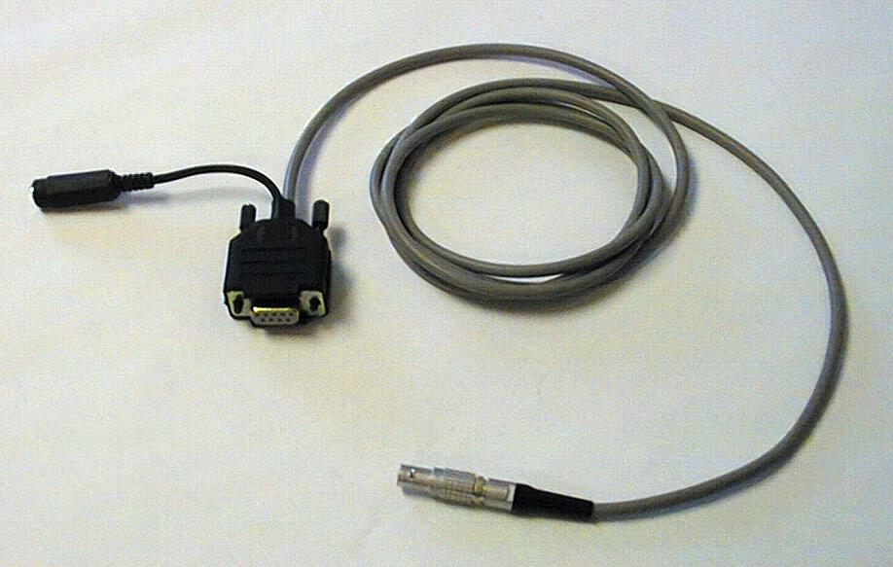
The PC download cable is used for downloading data to and from the datalogger if the RF link is unavailable/not fitted. In addition the cable is used in conjunction with the dc power supply to recharge the dataloggers batteries. For more information see section 4.1.

2.4 DC Power Supply
The mains powered DC power supply is provided to allow the internal batteries to be charged and/or to allow the unit to operate from a mains source. The unit is plugged into the flying lead on the serial download cable which in turn is plugged into the datalogger.

Only the dc supply shipped should be used to charge/power the datalogger. Use of a third party

supply could damage the datalogger.

2.5 PC transceiver unit
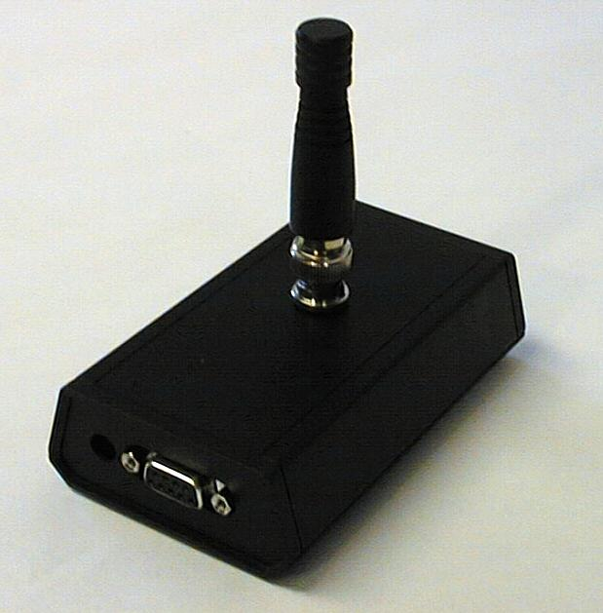
The PC transceiver unit is only shipped with systems which have the optional RF telemetry fitted to the logger. The transceiver unit allows the PC to communicate to the datalogger on a bi-directional RF link. The unit is battery powered and features automatic power on/off to optimise the battery life. The unit can also be powered from an external 12vdc supply via the integral jack socket. The unit is connected to a PC serial port using the 9way serial lead supplied.

2.6 PC Windows Software
The PROfiler software is suitable for most PC’s running Windows 95/98/NT4.0. A recommended minimum PC specifcation is included for guidance below:-
- Pentium class CPU 166Mhz or equivalent with 16MB Ram
- Windows 95/98 or NT4.0
- 10MB of free disk space
- 1 free standard serial port (9way or 25way with 25-9way converter)
- Dual speed CD Rom drive or internet access
- VGA Monitor (15” or bigger recommended)

The software is supplied on CD Rom as standard, however the latest software can also be downloaded from the Circuitmaster website (www.circuitmaster.co.uk) if you have internet access. The website also contains hints,tips and FAQ information which you may find useful.

2.7 Software Installation

It is strongly recommended that before you begin installing the software you shut down all other applications on your machine and reboot it.
- Insert the PROfiler CD ROM into your drive (usually “d”) and close the door.
- The software has an autorun file so the installation software should run up automatically.
If for any reason this fails to happen proceed as follows:-
- Click on start then run
- Type d:\setup.exe (where “d” is the letter of your CD ROM drive)
- Follow the on screen instructions.

2.8 Siteing the PC RF transceiver

The position of the PC RF transceiver unit is not ultra critical. The unit has a magnetic base to allow it to easily be attached securely to a convenient ferrous metal surface (e.g an oven). The performance of the RF link is dependant largely on the surrounding environment, which cause null regions, and multi path reflections. A few suggested places are:-

- A short distance from one end of the tunnel.
- On top of the Oven
- To one side of the oven.

2.8 Testing the System
Once the software has been installed, follow the instructions below to make sure your PROfiler system is working correctly. This procedure will also help you become familiar with the various parts of the PROfiler system.

2.8.1 Testing Direct Communications
- Connect the PC download lead to the data logger Comms socket
- Connect the DC power supply to the dc socket provided on the opposite end of the download lead (flying lead).
- Plug the DC supply into the nearest mains power outlet and switch on the datalogger
- Plug the 9 way connector into the serial port onto your PC
- Run up the PROfiler software and move to the datalogger settings tab.
- Select direct connection mode using the radio buttons towards the bottom left of the screen in the communication mode group box.
- Press the request button, and the serial number, calibration date and battery level information should be updated in the logger information group box. This test checks that the datalogger is working and is communicating down the serial lead.

2.8.2 Testing RF Communications

If you have the RF telemetry option fitted, you can test the RF comms as follows:
- Connect the PC download lead to the data logger Comms socket
- Connect the PC transceiver to the PC with the serial lead provided.
- Connect the DC power supply to the dc socket provided on the opposite end of the download lead (flying lead).
- Plug the DC supply into the nearest mains power outlet and switch on the datalogger
- Run up the PROfiler software and move to the datalogger settings tab.
- Select RF communication mode using the radio buttons towards the bottom left of the screen in the communication mode group box.
- Press the request button, and the serial number, calibration date and battery level information should be updated in the logger information group box.
This test checks that the datalogger is working and is communicating over the RF link.

3.0 Profiling Basics

In reflow and wave soldering it is vital, due to the volume and value of subassemblies and boards being processed, to be able to measure and analyse certain critical process conditions in order to be able to guarantee the consistent quality and reliability of finished products. Given the number of variables and the ever increasing complexities of modern microelectronics, as well as the increasing use of mixed technologies it is vital that a process engineer can pinpoint problem areas quickly and cost effectively in order that he can make an informed judgement and take the right corrective action.
Thermal profiling involves the accurate temperature measurement and logging of certain special sites on a printed circuit board whilst the board is being processed through a reflow or wave soldering machine. The resulting graph of temperature versus time can be analysed to obtain maximum and minimum temperatures, temperature differences, times at temperatures and temperature gradients and other valuable process metrics.
This information can be stored and checked periodically to prove process control and stability to customers and can also be used as the basis for measurable process quality improvement.

3.1 Operating Modes
There are two ways in which the system can operate
- Standalone Mode
- Realtime Mode

3.1.1 Standalone Mode
This mode operates in the same way as a conventional datalogger would operate.
- The PROfiler system is plugged into the test board, to which thermocouples have been previously attached.
- The logger is powered up and logging is started using the mode button on the front panel.
- The datalogger is fitted to the thermal barrier and the unit is placed on the oven conveyer system.
- The logger samples each enabled thermocouple channel in turn and takes a temperature reading. The reading is then stored in the loggers internal memory for download at the end of the run. The sampling rate and channels to sample are setup using the PC software and comms lead prior to the run.
- Once the logger emerges from the oven the datalogger is removed from the thermal barrier and the download lead is connected between the logger and the PC.
- The PROfiler software can then be used to download the contents of the dataloggers memory to the PC for analysis and to be saved off to disk.
The standalone mode is particularly suited to oven referencing and periodic checking. Under these circumstances it is not necessary to view the profile in real time. The profile can be downloaded at the end of the run offline, perhaps on a remote office PC, where it is analysed and stored away.

3.1.2 Real Time Mode
The real time mode of operation is primarily intended for units with the RF option (Real Time RF mode). In such cases the system operates as follows:-
- The PROfiler system is plugged into the test board, to which thermocouples have been previously attached.
- The logger is powered up and logging is started remotely via the PC and telemetry link .
- The datalogger is fitted to the thermal barrier and the unit is placed on the oven conveyer system.
- The logger samples each enabled thermocouple channel in turn and takes a temperature reading. The reading is then stored in the loggers internal memory. Additionally the logger sends the data samples to the PC in real time using the RF data link, the PC software is therefore able to produce a live trace of the run as it happens.
- The sampling rate and channels to sample are setup using the PC software and RF telemetry link prior to the run.
- Once the logger emerges from the oven the datalogger is removed from the thermal barrier to allow it to cool down. The PROfiler software can then be used to analyse the data and save it to disk.
In this mode, the temperature data is only stored in the dataloggers internal memory until it has been successfully transferred to the PC thus increasing the effective data recording capacity of the system. Successful transfer to the PC is guaranteed by way of the two way RF link.

The Real time RF mode is particularly suited to job setup. The fact that the RF telemetry allows the profile to be seen ‘as it happens’ allows a trained engineer to make informed decisions more rapidly. Problems can be detected faster, and remedial action taken before the PROfiler system has even emerged from the oven. The benefits in reduced setup time are obvious.
In addition to logging in realtime using the RF telemetry, it is possible to log in realtime using direct communications with the PC download lead connected. This mode is useful in temperature logging applications which do not involve conveyor systems and/or the datalogger can stay at or close to the ambient environment.
As an example, consider a datalogging applications involving a batch oven, were the datalogger can be left outside the chamber and thermocouples are fed in through a convenient aperture in the oven.
Real time temperature datalogging can be achieved over long periods by connecting the PC to the datalogger via the download lead and powering the datalogger from the dc power supply..

3.2 Profiling a Board With PROfiler
By now you should be reasonably familiar with the various parts of the PROfiler system, and ready to profile your process. The following sections take you step by step through profiling your process. You will need the following additional items :-
- High Temperature Solder and/or Kapton tape
- Suitable test board
- Soldering iron

3.2.1 Preparing the test board

In order to profile your reflow or wave solder process it is first necessary to attach the thermocouples to a suitable test board or jig. Typically a test board is used which representative of the job being processed on the machine at that time.
The best way to attach the thermocouples to the test board is to solder them to points of interest using high temperature solder. The high temperature solder is used so that the thermocouples remain attached to the test board throughout the run. Try to attach the thermocouples with as little solder as possible as increasing the effective junction area of the thermocouple (with a solder ball ) increases its thermal inertia and reduces its response time. An alternative method is to use Kapton tape to hold the thermocouples in contact with the board. Various high temperature adhesives are also available.

3.2.2 Where Do I position the Thermocouples ?

The positioning of the thermocouples depends on the board being processed. The basic idea is that the board temperature is increased uniformly at a controlled rate up to the liquidous point of the solder, is held above this point for a short time and is then cooled at a controlled rate.
Components with a high thermal inertia such as large coils, transformers etc obviously require more energy to raise their temperature at the same rate as a component with a low thermal inertia, for example an 0805 resistor. The goal is to achieve as uniform a temperature across the board as possible before the board temperature reaches the liquidous temperature of the solder to ensure that all components are soldered properly and also to reduce the risk of warping the board.
The extremes of temperature difference across the board is known in the industry as the board delta –T.

In addition to minimising delta-T on the board being processed, there are two other main processing metrics. The first is the rate of change of temperature, i.e. how fast or slow we change the temperature and the second is the time the solder is in its liquid state known as time in liquidous.
Figure Time above the liquiduous point
Tl

tl

The rate of change of temperature is simply the slope of the profile. The steeper the slope either positive (heating) or negative (cooling) the higher the rate of change of temperature.
Heating Slope
(+ve)
Cooling Slope
(-ve)
Figure Rate of change of Temperature

A high rate of change of temperature increases the thermal shock on the component (Heated or cooled quicker). This metric is particularly important when soldering plastic encapsulated devices as a sudden change in temperature causes the plastic encapsulant and device leadframe to expand at different rates. This causes a void to appear between the devices leads and encapsulant that can trap moisture and cause internal oxidisation of the device leadframe and bonding, often manifesting itself in long term reliability problems.

The time in liquidous is specified by the solder manufacturer and is an important process metric. Two short a time in liquidous, and the solder will not flow properly and soldering will be incomplete. Two long a time in liquidous and all the flux will be evaporated causing the joint to become dry and unreliable.

When temperature profiling, the above points should be considered carefully when choosing the location for the thermocouples. Try to predict the areas for a particular board where any problems are likely to occur, for example :-
- Components with a high thermal mass
- Components shielded by other taller components (shadowing).
- Components at the extremes of the board
- Components in areas which are especially densely populated.

3.2.3 Setting up the PROfiler system

Once the testboard has been prepared, the thermocouples can be plugged into the PROfiler datalogger and the datalogger can be setup to record the profile. Regardless of whether your PROfiler has the optional RF telemetry option fitted or not, the parameters to setup are the same. There are four things to do:-
- Setup the oven zones to match your oven / load an oven template.
- Set the Process Settings
- Record the probe locations
- Set the datalogger settings

3.2.4 Setting Up Oven Zones

The number and size of zones on modern reflow ovens varies depending on the make and size of the oven. The PROfiler software allows the number and details of the zones for your oven to be configured. The default settings are :-
4 zones (Preheat,Soak,Reflow,Cooling) (All 1000mm in length)

Upper and Lower heater temperatures are the same for each zone at 100,160,240 and 50 respectively.
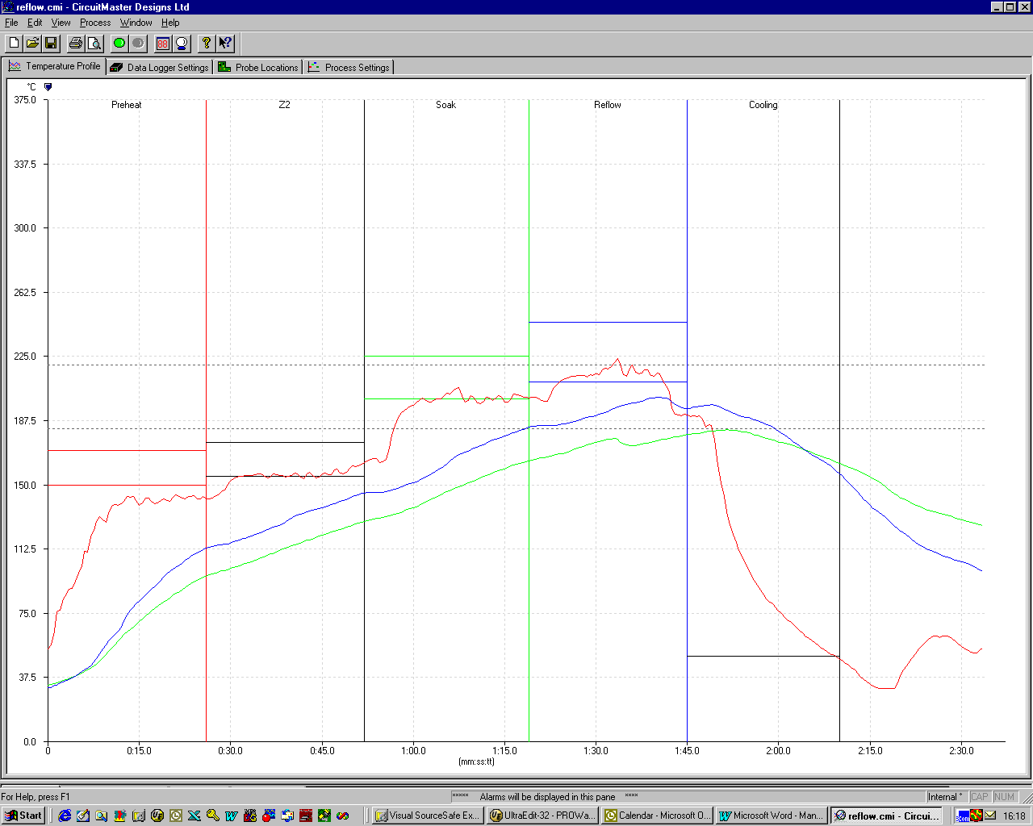
Zone Boundaries

Upper & Lower Zone Temperatures

The zone settings are marked on the temperature profile tab. The zone boundaries are marked as coloured vertical lines and the upper and lower zone temperature are marked as solid coloured horizontal bars. These zone boundaries can be dragged by moving the mouse over the horizontal or vertical zone line of interest and then dragging the line whilst holding down the left mouse button.
Alternatively you can use the Zone Configuration dialogue as follows:-
- Move the mouse over an oven zone boundary line, the cursor will change.
- Double click the left mouse button and the Zone Configuration dialogue is displayed.
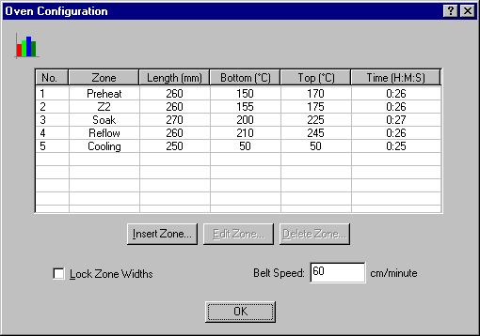

- Select a zone to edit by clicking on the relevant zones row in the list to highlight it.
- Press the Edit Zone button and fill in the relevant details.
- Press OK to save the changes
It is also possible to delete and insert zones using the Delete Zone and Insert Zone buttons in a similar fashion.
Once the oven zones have been set correctly it is advisable to tick the LOCK ZONE WIDTHS tick box
to avoid accidently moving the zone markers subsequently.

The belt speed edit box allows the machine conveyor speed to be input. Either read this from the machine control system if it is available or calculate the speed as follows:-
- Mark two visible points on the side of the oven adjacent to the conveyor, one on the entry and one at the exit.
- Accurately measure the distance between the points in centimetres (1m=100cm)
- Run the conveyor at the speed in question and place an object (e.g. blank board) on the conveyor. Accurately measure the time in seconds for the board to pass between the two points.
- Calculate the speed using
speed(cm/min) = Distance measured between points (cm) /
Time to pass between points (secs) x 60

3.2.5 Creating / Loading Oven Templates
In order to avoid having to setup the zone widths and temperatures each time you use PROfiler, or move from one oven type to another, a facility exists to save away a template file for a given oven. Once the zone information has been entered and a template is created, the template can be subsequently be loaded before profiling in order to speed up setup.
To create a template file for your oven proceed as follows:-
- From the main menu bar select file->new to open a blank profile window.
- Setup the zone information for your oven as described in the section Setting Up Oven Zones.
- From the main menu select file-> create template.
- In the create template dialogue enter a unique template name and a suitably descriptive comment.
- Press OK.

To Load a template :-
- From the main menu select FILE NEW.
- From the Oven Templates dialogue select the Template name you wish to load and press OK.
The template will load, and the zone and oven information will be automatically setup for you.

NOTE: Templates can be deleted,added and edited from the Oven Templates dialogue.

3.2.6 Process Settings

The process settings are setup on the Process Settings Tab. This tab is used to record details about the process which are stored along with the results of the profile. The following items should be entered here:-
Operator Name
A record of who performed the profile
Job Name
A record of the job being processed on the machine at this time
Batch Number
The Batch or Lot number of the product being processed on the machine at this time.
Oven Recipe
The oven settings or recipe name running on the machine at this time.
Oven ID
The unique machine serial, asset or ID number for the machine being profiled.
Oven Speed
A slider control is included and should be set to correspond with the conveyer speed of the oven. This parameter is used for calculations concerned with alignment of probe readings.

Notes
A free format area to allow any other documentation to be stored.

3.2.7 Recording the Probe Locations

The probe locations can be recorded graphically on the Probe Location Tab. In order to meaningfully compare a profile with one performed at an earlier time or on a different machine it is important that the probes be placed in the same place on the test board. The Probe Location Tab allows the thermocouple positions to be recorded graphically, by placing numbered thermocouple icons on a user supplied graphical image of the board. This information is saved along with all other settings considerably easing the task of comparative testing. The graphical representation of the board can be a sketch from a paint package, a scanned image or a photo from a digital camera.
In addition the thermocouple channels can be renamed allowing the user to add a more descriptive description of the point the probe is monitoring.
To import an image of your board:-
- Go to the Probe Locations tab
- Press the Select Image Button
- Navigate to the directory where your .bmp file resides
- Select the file and press OK

To place a thermocouple icon on the image:-
- Move the mouse over the thermocouple you wish to place, the cursor will change.
- Press and hold the left mouse button whilst dragging the icon over the image to the desired place.
- Release the mouse button to drop the icon in place.

To rename a thermocouple probe:-
- Move the mouse over the thermocouple you wish to rename.
- Double click the left mouse button.
- Enter the new name and a comment, then press OK.

3.2.8 Setting up the PROfiler datalogger

The final stage in setting up for the profile is to actually setup the PROfiler datalogger. There are just three settings to make.

- Setting the active channels

The first setting is to tell the PROfiler datalogger which channels have thermocouples connected. There may be times when it is not desirable to go to the effort of fitting thermocouples to all channels of the logger , particularly on smaller boards or on boards with relatively few components.

The Logger Settings tab allows the active channels to be setup using labeled tick boxes.
To select a channel tick the relevant box, and to deselect the channel untick it.
NOTE If a channel is not selected and a profile is performed, the PROfiler system does not take measurements from that channel. Instead internal logger memory space is allocated to selected channels, allowing more readings on the selected channels to be gathered.

- Setting the sampling period

The second setting to be made on the Logger Settings tab is the sampling period. The sampling period is the period in milliseconds (1000mS = 1Sec) the PROfiler datalogger waits before taking successive readings. Each sample period a reading from all the active channels is taken and stored.

A fast sampling period will show fast changes in temperature but requires more memory to store the results. A slow sampling period requires less memory, but some fast changes may not be recorded. The default setting is a sampling period of 500mS (0.5 Second) which is optimum in most situations.
Logging is started either by pressing the MODE button or using the START SAMPLING button on the datalogger tab depending on whether you have the RF telemetry option fitted. Logging is stopped in the same way.

NOTE When the logging in real time mode a message may sometimes appear after logging has stopped, informing you that some data is still buffered in the datalogger. This simply indicates that the datalogger has had to buffer some data due to poor comms on the rf link, and has not been able to clear the backlog before the run ended. The remaining data should therefore be downloaded.

You might try relocating the PC transceiver unit to see if better comms can be achieved.

- Setting the Communications Mode
Once the settings above have been completed, they must be downloaded to the datalogger. There are two ways of achieving this and the way you do it depends on which mode the datalogger will be run in.
If your PROfiler system does not have the RF option fitted, or if your RF PROfiler is to be run in the standalone mode proceed as follows:-
- Attach the PC download cable to the PC.
- Select the Direct Communications mode radio button on the datalogger settings tab.
- To update the datalogger with the settings made in 1 & 2 above press the UPDATE button.
The datalogger has now been setup. The download lead may be disconnected, and the unit is ready to use. To start sampling momentarily press the green MODE button. The red STATUS led will flash faster when the unit is logging. The unit can be stopped by again momentarily pressing the MODE button.

If your PROfiler system has the RF option fitted proceed as follows:-
- Attach the PC transceiver to the serial port via the serial lead provided.
- Select the RF communications mode radio button on the datalogger settings
- To Update the datalogger with the settings made in 1 & 2 above press the UPDATE button.
At this point is worth pressing the REQUEST button. This will update the battery level meter with the current battery level. You should check this before starting a run in order to make sure there is enough energy in the batteries to allow te profile to be captured and downloaded. As a general rule a battery level greater than 20% is ok for profiling, below this the batteries should be charged.

The datalogger has now been setup and is ready for use. To start sampling press the START SAMPLING button on the data logger settings tab.The red STATUS led will flash faster when the unit is logging. To stop the logger, again momentarily press the green MODE button.

3.2.9 Loading the System into the Oven
Having setup the system for a temperature profile run, all that remains to be done is to load the datalogger into its thermal barrier (if reflow profiling) and load the test board and complete PROfiler system onto the oven conveyor.

3.2.10 Loading the datalogger into its Heat Barrier
To load the datalogger into its thermal barrier:-
- Open the thermal barrier by squeezing the corner of the enclosure with the finger and thumb of one hand whilst pulling the catch and then rotating anticlockwise a quarter turn with the other. The catch should lock in the open position. Repeat for the other catch.
- Plug the thermocouples into the logger and place it into the bottom of the barrier. Tidy the thermocouple wires by looping any slack and binding with kapton tape. This will make loading and unloading the test board and PROfiler system on the conveyer system easier. Remember to leave enough length on the thermocouple cables so that the PROfiler system follows far enough behind the test board to avoid its thermal mass influencing results.
- Close the barrier lid making sure thermocouple wires and the logger antenna exit the thermal berrier at either end over the silicon foam seal where the lid is recessed for cable access. The lid is necessarily tight in order to provide a good seal and adequately protect the datalogger. Squeeze the corner of the enclosure with the finger and thumb of one hand whilst rotating the catch clockwise and releasing to engage it.

With the datalogger loaded into its barrier the complete assembly can be loaded onto the oven conveyor system. If the oven has a mesh belt place the board onto the belt first, feeding the PROfiler system on as the board is transported forward. Feed the assembly in carefully ensuring that trailing thermocouple wires and the datalogger antenna cannot foul in any part of the oven transportation system.
If no belt is available and an edge feed pin and chain system is used an optional transportaion jig will be required. This unit is also useful if the aperture of the oven is too small as on some nitrogen inerted ovens. The jig is fully adjustable in height and width and allows the PROfiler system to be centralised about the edge feed pins. Contact your local representative for details.

3.2.11 Recovering the System from the Oven

Once the PROfiler system has traversed the oven it along with the test board must be recovered and quickly dismantled to allow the unit to cool down. This process is essential the reverse of loading but great care must be taken as the barrier and test board will still be hot.
NOTE Hand Protection MUST ALWAYS BE USED when recovering the system from the Oven

The system is recovered and dismantled as follows.
- Well before the system emerges from the oven, clear a suitable nearby site for dimantling the system. It may be necessary to protect the intended work surface/bench from the heat of the unit by placing a metal sheet or insulation mat so that the barrier does not directly contact the surface in question.
- Just before the system is about to emerge from the oven, put on protective gloves or other suitable hand protection..
- As the unit emerges from the oven pick up the test board with one hand and allow the PROfiler system to be fed out of the oven on the conveyor. Make sure any training wires cannot foul on moving parts.
- Pick up the datalogger with your other hand and take it to the area previously prepared for dismantling.
- Still wearing hand protection open the heat barrier by squeezing the corner of the enclosure with the thumb and finger of one hand whilst pulling the catch and rotating anticlockwise a quarter turn with the other. Repeat for the other catch.
- Remove the datalogger from the barrier along with the test board and trailing wires.
- Place the heat barrier in a suitable safe place to allow it to cool down.
- After removing the hand protection used, unplug the test board from the datalogger.
- If the datalogger was being used in STANDALONE MODE the green mode button should be momentarily pressed in order to stop the datalogger logging. The datalogger should then be placed in a suitably safe place to allow it to cool down.

3.2.12 Internal Logger Temperature

The PROfiler datalogger is not designed to withstand the heat typically employed in reflow and wave soldering processes unprotected. The datalogger must be fitted to its protective metal barrier for reflow profiling, and must be used in conjunction with its protection mat for wave soldering.

NOTE Always remove the datalogger from its protective barrier as soon as it emerges from the reflow oven.

The internal logger temperature is displayed in real time on the Profile Tab in the bottom right hand corner if profiling using the RF telemetry option. The display background will change colour to indicate the status of the temperature. Never use the logger if the internal temperature display background is RED or the internqal temperature is greater than 55deg C.
NOTE The PC software may warn you upon starting a profile run that the datalogger is too hot. If this happens do not be tempted to try another profile run. Allow the datalogger sufficient time to return to ambient temperature before completing the run. Failure to do this could damage the datalogger.

3.2.13 DownLoading data from the datalogger
When the PROfiler datalogger emerges from the machine if your system has the RF telemetry option, you already have the temperature profile displayed on your PC if you where logging in realtime. If not you can download the data over the RF link by using download button on the datalogger tab. If you have the PROfiler system without the RF option you can download the profile using the PC download lead as follows:-

To download data using the download lead:-
- Connect the PC download lead to the data logger Comms socket
- Plug the 9 way connector into the serial port onto your PC
- Run up the PROfiler software and move to the datalogger tab.
- Select direct communications mode using the radio buttons towards the bottom of the screen
- Press the download button, the progress bar indicates the amount of data remaining.
- When the download is complete the progress bar is cleared again.

3.3 Saving your profile information
Regardless of the method you used to download data from the datalogger, before you go any further you should save the information you have downloaded.

Save off the results as follows:-
- Select the FILE option from the main menu bar
- Then select SAVE AS, navigate to the correct folder and name the file with a meaningful name.
- Be sure the SAVE AS TYPE is set to *.CMI
- Press OK.

PROfiler has an option available to prompt you to save the data whenever you stop sampling in the REAL TIME mode or download data from the datalogger in the STANDALONE mode. The software also suggests a unique file name based on the date along with a number and a letter.

To enable the Auto Save Prompt Upon Stop Sampling feature:-
- From the main menu select EDIT
- Select the menu item DEFAULT SETTINGS
- On the Default Settings dialogue select the general settings tab.
- Tick the Auto Save Prompt Upon Stop Sampling tick box and press OK.

3.4 Measuring process metrics

Having saved the results you can now analyse the profile for the important process metrics which are :-
- Board delta–T.
- Positive and negative rates of change of temperature.
- Time above the liquidous temperature.

3.4.1 Displaying board delta–T

To view instantaneous delta-T on the graph:-

- Select the temperature profile tab
- Notice that moving the mouse around over the graph causes the panel meters to show the time and temperature at that point.
- Holding the cursor over the graph, press the right mouse button to bring up a popup menu, and select Lock Cursor To Channel.
- Select one of the channels on the profile you have loaded.
- A cross and vertical marker line appear, as does an additional panel meter – Delta-T. Notice also the data view window opens at the bottom of the screen.
- The additional panel meter shows the Maximum Delta – T (Temperature difference) at the cursor position along with the two channels numbers between which the difference exists. This information is also available in the data view window at the bottom of the screen under the column heading Peak Diff. The data view window also shows the temperature at the cursor position for each of the channels and also the slope about the cursor position.
NOTE: The number of points used to calculate the slope at the cursor position can be set using the ANALYSIS OPTIONS dialog on the data analysis tab.
- Moving the mouse along causes the meters to update with new cursor information.

To view the maximum delta-T on the whole profile:-
- Select the Data Analysis tab
- Select Peak Difference from the drop down list
The table shows the peak delta-T which occurred between any two channels, along with the channels concerned. Additionally the table shows the channel temperatures at the time the peak difference occurred and the peak difference in degrees C.

3.4.2 Displaying Positive and Negative Rates Of Change

In order for PROfiler to the slope at spot points on the graph, it is first necessary to setup the number of points over which the slope is calculated.

To set the number of points over which slopes are calculated:-

- Select the data analysis tab
- Select Analysis Options
- Select the Slope Analysis Options tab
- Set the number of readings used to determine the slope using the spin control provided.

To display positive and negative slopes on the profile graph:-

- Select the temperature profile tab
- Notice that moving the mouse around over the graph causes the panel meters to show the time and temperature at that point.
- Holding the cursor over the graph, press the right mouse button to bring up a popup menu, and select Lock Cursor To Channel.
- Select one of the channels on the profile.
- A cross and marker line appear, as do an additional panel meter and data view window at the bottom of the screen.
- The additional panel meter shows the Maximum Delta – T at the cursor position and the channel numbers concerned.
- Moving the mouse along causes the meters to update with the new information
- The data view window shows the slope averaged about the cursor position over the number of points specified on the Slope Analysis Options tab.

To display maximum positive and negative slopes for the profile:-

- Select the Data Analysis tab.
- Select Maximum Slope Analysis from the drop down list..

The table shows the maximum slope in degC/sec for each of the profile traces and the time at which they occurred.
NOTE A negative slope occurs during cooling down and a positive slope occurs during heating. The information can be viewed on a zone by zone bases by ticking the calculate by zone tick box located at the bottom of the tab.

3.4.3 Displaying the time above the liquidous temperature

You can have PROfiler show the time above an arbitrary temperature using the Time above Temperature analysis option.
The first step is to set the temperature of interest:-
- Select the Data Analysis tab
- Select Analysis Options
- Select the Time Above Temperature Options tab
- Enter the temperature of interest using the spin control provided.

To display the time above the temperature entered:-

- From the data analysis tab, select the Time Above Temperature Analysis from the drop down list.
The table shows two results, the time to reach the temperature from the start of the profile, and also the total time above this temperature.

3.5 Adding a Process Tolerance
During production, once a process is established the primary concern of the production Engineer is to measure how stable the process is and ensure that if the process becomes unstable :-
- Production is stopped in a timely manner to avoid producing defects.
- Corrective action is taken to restore process stability.
All production processes are subject to some random variation. It is however, the process Engineer’s responsibility to specify what is and is not acceptable by specifying a process tolerance.
PROfiler allows a process tolerance bar to be added on screen. This visually aids a user to determine quickly whether a process is still acceptable, or whether the process has deviated from the process norm.
In order to create a tolerance we need first something to create the tolerance on. PROfiler allows tolerances to be created based on two features of the profile:-
- Using any single channels profile
- Using the spread of all the active channels profiles (peak difference).
Having decided whether we should create a tolerance on a single channel profile or on the spread of all of them, we must then decide what the tolerance should be. This is the amount we determine is acceptable above and below either the single channel profile or the band or spread of all the channels.

To create a tolerance for a profile:-
- From the main menu select FILE and TOLERANCE CURVE.
- The tolerance curve dialogue box will appear
- Select the tolerance type using the radio buttons, if you select BY PROBE be sure to select the probe you want using the list box provided.
- Using the spin controls at the bottom of the dialogue set the positive and negative tolerance in deg C or F whichever is active at the time.
- Press CREATE and the tolerance curve will be displayed on screen.

NOTE the tolerance curve information is stored in the template for future use.

3.6 Overlaying a Profile
There are occasions when it is useful to be able to overlay one profile over another for comparative processes. For this process to be at all useful, the two profiles to be overlayed must have been captured at the same sampling rate.
To overlay on profile over another::-
- With one profile loaded, from the main menu select FILE – OVERLAY PROFILE
- From the file open dialogue select the file to overlay.
- The profile will be overlayed.
To clear the overlayed profile select FILE – CLEAR OVERLAY from the main menu.

3.7 Exporting Data

For more advanced analysis and manipulation of results the profile data gathered from the PROfiler datalogger can be exported to allow the use of spreadsheets and other analysis tools.
To export the profile information to a spreadsheet proceed as follows:-
- Select the FILE option from the main menu.
- Select Save As.
- On the dialogue box which appears select *.csv from the Save As Type drop down.
- Navigate to the correct folder you wish to save the exported file to, then choose a meaningful filename and press OK.

The file format of the exported file is CSV or Comma Separated Value which can readily be imported to packages such as Excel, Access and the like for further manipulation.

3.8 Printing

Although the results and settings of the profile are saved whenever you save off the file as a CMI file, there are however times when a paper copy is required, for example as documentary evidence for ISO conformancy.
PROfiler provides a clear, easy to read standard printout with all the relevant process and analysis information tabulated, along with the profile graph. A print preview facility is also available.
To Print preview the report:-
- From the File menu select Print Preview
- The preview of the report is shown on screen.
To Print a report:-
- From the File menu select Print
- Press OK on the dialogue box that appears.
NOTE The analysis information can be omitted from the printout, this is done by way of the default settings.

3.9 Alarms
The bottom area of the profile tab is reserved for alarms which are system warnings. These alarms are generated under the following conditions:-
- Data communications lost between the datalogger and the PC in RF real time mode.
- Logger over temperature warnings
The alarms can be cleared by simply double clicking on the alarm.

3.10 Default Settings

The default settings for the PROfiler software can be edited by way of a default dialogue. The settings available are:-
- Units of Temperature Celsius or Fahrenheit.
- Your company details.
- PC serial port to use.
- Auto Save feature
- Printout options
- Max Temperature to display on Y axis.
To edit these settings:-
- Select EDIT from the menu bar
- Select DEFAULT SETTINGS
- Edit the settings and press OK.

4.0 Care And Maintenance

Datalogger
The datalogger should provide a long service life if treated in accordance with this manual and the points in this section are heeded. Keep the following points in mind:-
- ALWAYS remove the datalogger from its protective barrier as soon as possible.
- NEVER leave the datalogger in its barrier after completion of a profile run. The unit will continue to heat up after it has been removed from the oven.
- DO NOT attempt to charge the batteries until the datalogger has cooled back to ambient temperature.
- NEVER be tempted to start another run when the datalogger and or barrier have not been left to cooldown sufficiently.
- For optimum battery life try to cycle the batteries (charge then exhaust). As a general rule charge the batteries when they show 20% on the battery monitor.
If the cycle time of the system is deemed too long due to the time it takes to allow the components to cool consider the following:-
- Employ some form of forced cooling such as a fan, heatsink or refrigeration.
- Purchase a second barrier
- Purchase a second PROfiler system.

Heat Barrier
The heat barrier should be checked regularly to ensure a good seal is still being made when the unit is closed. The barrier can be cleaned externally with a soft cloth and a small amount of IPA (Isopropyl Alchohol) in order to remove grease and dirt from the enclosure surface.

4.1 Battery Charging

The PC transceiver module features automatic power on/off and consumes very little power. This unit therefore uses a standard PP3 alkaline cell. The PROfiler datalogger unit is fitted with NiMh rechargeable batteries. The unit has a built-in charger circuit which will charge the batteries if required, when the external DC power supply is plugged in. The battery charging is controlled by the datalogger microprocessor, and therefore the unit must be powered up whilst charging is in progress. Whenever the external DC supply is plugged in, the unit will draw power from it rather than from the batteries. The unit can therefore be plugged into the DC source when not in use, and the unit will charge the batteries when required. After charging has terminated, the unit will stay active, but will draw power from the external DC source rather than drain the batteries, in this way the datalogger will always be ready for use.
To charge the datalogger batteries:-
- Plug the PC download cable into the datalogger comms socket.
- Plug the DC power supply into the dc socket on the download lead.
- Plug the DC power supply into the wall socket and turn on the datalogger.
The battery charging has two modes :-
- Fast Charging
- Trickle Charging
If the battery level is below 80% of capacity, the datalogger will fast charge its batteries, this is signified by the green CHARGE led being lit continuously. If the battery level is above 80% of capacity the datalogger will trickle charge its batteries which is signified by a flashing green CHARGE led. The datalogger also reverts to the trickle charge mode when the batteries have been fully fast charged.
NOTE If the internal temperature of the unit is excessively high or low allow the datalogger to cool/heat to ambient before attempting to charge the batteries.

If ever the batteries are exhausted and the unit must be used immediately, it is possible to remove the rechargeable batteries and use standard AAA cells on a temporary basis. If operating under these conditions, under no circumstances should the external DC power supply be connected to the datalogger.

4.2 Changing the Batteries

The datalogger uses NiMh AAA rechargeable batteries and these should provide a reasonable service life. It is important that the batteries are only replaced with batteries of the same type. Since the batteries are designed to be replaced infrequently, the datalogger must be dismantled to replace them.
To replace the dataloggers batteries:-
- Remove the four screws from the datalogger cover and remove them.
- Remove the four screws retaining the circuit board in the case.
- Plug in the comms cable and using the plug to prevent the comms connector from turning, unscrew the outer securing ring.
- Slide the circuit board forward so that the thermocouple connectors protrude through the slot in the box. Ease the opposite edge of the board up (switch end) making sure the comms connector and switch do not foul on the box edge. Completely remove the circuit board from the box.
- The batteries are in clip in connectors. Replace the batteries observing the correct polarity. The positive end of the battery (+) is the ‘pip’ end and the negative end (-) is the flat end.
- Reassembly is the reverse or dismantling, remembering to use the download lead plug to prevent the comms socket rotating as the outer securing ring is tightened.

To replace the PC transceiver battery:-
- Open the battery compartment by depressing the clip on the battery compartment end of the unit.
- Withdraw the battery from the unit and disconnect the battery from the battery connector.
- Connect the new battery and fit the battery back into the battery compartment.
- Replace the battery compartment lid making sure the clip snaps back into place.

4.3 Software Updates
Although every effort is made to make sure that the software shipped to you the customer is error free, there will inevitably be occasions when this is not so. In addition, we may make modifications to the software to add new features for example, and it is desirable that the datalogger and PC software can be easily upgraded.
An windows upgrade utility is included for the datalogger on the CDROM. The utility can be installed and run allowing a new object code file to be downloaded to the datalogger.
New datalogger object code files and PC software will be published on the CircuitMaster web site periodically.

4.4 Product Conformance
This product has been tested and conforms with EC Directive 89/336/EEC BS EN 50081-1/ 50082-1 Immunity & Emission Standards. Further details of the testing carried out are available on request.

5.0 Technical Specification

DataLogger
Sensor Type Type K Thermocouple
Dimensions 115x115x23 (mm)
Measurement Range -150degC – +600deg C
Sensor Channels 6
Sample Period 0.2s – 10minutes (All Channels Active) , 0.1s-10minutes (1-4 channels active)
Data Buffer 40,000 data points optimised over active channels
Measurement Resolution 0.02 deg C
Measurement Accuracy +/- 1deg C
RF 433Mhz FM Bidirectional ERP 1mW
Antenna 16cm Whip
Power 2x NiMh AAA cells 550mAh
Charge Time 2 Hours flat to fully charged
Operation 5hours continuous from a single charge (Approx 30 profile runs)
Mains Rejection Greater than 90dB
Max Internal Temperature 55deg C
Endurance 10minutes @ 200deg C in standard barrier
Conformance Conforms with EC Directive 89/336/EEC BS EN 50081-1/ 50082-1

PC Transceiver

Input 9Way Dtype RS232
RF 433Mhz FM Bidirectional ERP 1mW
Antenna 433Mhz Helical
Power 9v PP3 300mAh
Operation Auto Power On/Off
Conformance Conforms with EC Directive 89/336/EEC BS EN 50081-1/ 50082-1

